Programming: Principles and Practice Using C++
By Bjarne Stroustrop
Notes:
“IDEA” – Keyphrase to denote when I had an idea to be able to use in the future
Bold – Any code references made in notes
Underline – New words/phrases and definitions

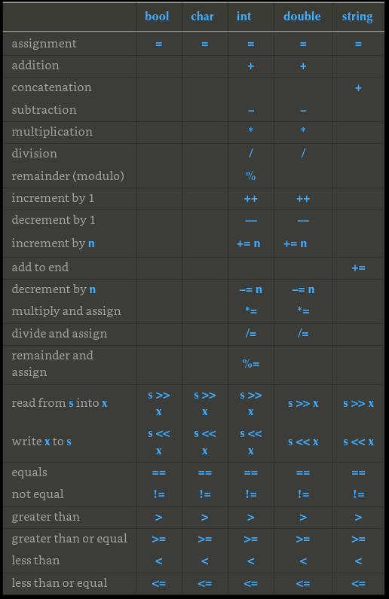
Chapter 3 – Object Types and Values

3.3 Input and Type
- Strings are terminated by whitespace (whitespace is ignored by >>)
- Always initialize variables to avoid uninitialized variables to be used → it can cause undefined errors
- Can input (if terminated by whitespace) multiple types with → cin >> name1 >> name2

3.4 Operations and Operators
- Variable type determines what operations can be applied. Compiler knows which type has what operations (common operators for common types in table to the right)
- Concatenate strings with + operator, word1 < word2 → word1 alphabetically before word2, word1 > word2 → word1 is alphabetically after word 2

3.6 Composite Assignment Operators
- ++counter → counter = counter + 1, a += 7 → a = a +7 (same for +, -, /, *, %)

3.7 Names
- _name → the underscore naming convention reserved for implementation and system entities
- USED_FOR_MACROS → reserved for macros. Avoid macros

3.8 Types and Objects
- Type is set of possible values. Object is some memory that holds a value of a given type. Value is set of bits in memory interpreted according to a type. Declaration gives name to an object, definition sets aside memory for an object.
- String keeps track of number of characters it holds
- Different types have different byte values, and depends on the OS

3.9 Type Safety
- Char to int conversion is type safe since there is no information lost (original → converted type == converted type → original)
- Narrowing conversion is unsafe and happens when cannot be turned back into original value
- Assignment using { } instead of = throws error if narrowing conversion

Chapter 4 – Computation

4.2 Objectives and Tools
- Job as programmers is to express computations correctly, simply, and efficiently. As a professional, code is meant to be added on over time and quality of code is the way to get it done.
- Abstraction involves hiding details that aren’t required to use a facility. Example of a function call with parameters, doesn’t need to know how it works, just need to know how to input parameters and deal with the output.
- Using C++ standard libraries are faster and involves less work. Use them whenever possible
- Ignoring structure of code requires more time to fix errors and are financially costly in the long run professionally

4.3 Expressions
- Ugly code hides logical errors and takes longer to comprehend (a key aspect for professional development with others)
- Use constants instead of random literals. Makes readability easier and can change value easier and not search for the literals’ uses all throughout the program. constexpr is compile time constant. const is runtime.
- 9/5 used as a literal == 1. 9.0/5 used as a literal == 1.8. If a double is involved, a double will be the result in binary operands

4.4 Statements
- To write many if() statements together, use else if()
- switch statements can only be used with int, char, or enums. Cannot switch a string. Cannot have a variable in a case label. (To switch with a string, use a map or if statement)

4.5 Functions
- Function call example: type identifier ( parameter-list ) function-body
- Programs usually easier to write and understand if each function performs a single logical action

4.6 Vector
- Range-for-loop vector<int> v {5,8,7,6}; for (int x : v) → for each x in v. Iterates through from 0 until v.size() (also known as the end assigning x the value (type of x matters) of the current selection from the vector
- Member function call example: object_name.member-function-name ( argument-list )

Chapter 5 – Errors

5.1 Introduction
- Error Types: link time error when trying to link object files into an executable file.
- Basic professionalism involves accounting for illegal inputs.

5.2 Sources of Errors
- Poor specification of what the program should do
- Incomplete program in the course of development
- Unexpected input, both from a user and another part of the program (arguments of a function)
- Unexpected state: Data (“state”) kept around by the program. If the data is incomplete or wrong

5.3 Compile Time Errors
- Syntax error means code is not formed according to C++ grammar. Look around where the compiler says the error is (compiler needs to check what comes next to determine if the previous line was an error)
(5.4 Link Time Errors. 5.5 Run Time Errors.)

5.5 Run Time Errors
- The function that was called should handle errors. Check the function’s arguments.

5.6 Exceptions
- Exceptions separate the detection of an error with the handling of an error. If the function finds an error that it cannot handle, the return value is not normal. It throws an exception indicating what went wrong. The caller can catch the exception (specify what to do if the called function used throw)
- Expresses exceptions using a try block (the observer to an error being thrown), listing the kinds of exceptions It wants to handle in the catch parts immediately following the try block, can be multiple. If no caller catches an exception, the program terminates. The code propagates up the stack to find the nearest catch of the same parameters of the throw. (IDEA: Can have an error class catching enums of error codes/descritpions, times, what got called, any meta data at that time)
- Syntax: throw object_type() → makes an object of type object_type and throws it. Can be used also as just throw “String to Throw” or any type desired to show an error has been thrown .
  - Int main(){
try {
functionThrowsAnException()
}
catch(object_type) { //handle error here }
- Easy common use is out of range errors thrown with vectors or arrays (or any lists) when using a variable based on the max size of the list
- Runtime error stores message. Throwing throw std::runtime_error( //something ) can be caught by a catch. The message parameters can be displayed using catch(std::runtime_error x) { cout << x.what(); } (passing by reference is faster than the full type copy)
- Use std::cerr to write errors because it makes code readable that the message is an error message and some OS’s have cerr write to files specifically
- Catching type exception itself is a more broad way of handling errors. Discussed later
- Template arguments are <...> used when need to specify a type rather than a value. Cast means type conversion.

5.7 Logic Errors
- Logic errors hard to find when coding. Must think logically through the flow of the program and what inputs.outputs are reasonable. Mostly found through testing phases

5.8 Estimation
- Comparing program output with estimated results determined by the programmer can determine if the results given by the program are plausible. We don’t need exact, that’s the programs job
5.9 Debugging
- Ask “how would I know if the program worked correctly”
- Before writing code, decide how to report errors.
- Make the code easy to read. Comment and document a lot. Say in the comments what can’t be said in the code.
5.10 Pre- and Post-Conditions
- A pre-condition is when the function is called only when the pre-condition is true. (Commonly used by checking the function callee’s arguments as the first step in the callee function. IE – if it expects an int, but is passed a string). If the pre-condition is violated (doesn’t hold), can either ignore it or check it an error report.
  - When checking, comment what it checks for, and what it expects input to be. Code example:
int area(int length, int width)
// calculate area of a rectangle;
// pre-conditions: length and width are positive
// post-condition: returns a positive value that is the area
{
if (length<=0 || width <=0) error("area() pre-condition");
int a = length*width;
if (a<=0) error("area() post-condition");
return a;
}
5.11 Testing
- Testing involves executing the program with a large and systematically selected inputs to compare results to what is expected. A single run is called a test case. This can be automated later.
Chapter 6 – Writing a Program

6.2 Thinking About The Problem
- Design shouldn’t be alone. Talk through it with another
- Evolve program through versions
- Stages of development:
  - Analysis: figure out what should be done and write a description of current understanding of that.
  - Design: create an overall structure of the system deciding how parts communicate. As part of the design, consider libraries or tools that can be useful
  - Implementation: write, debug, and test
- Be specific about what you are trying to accomplish by writing a description. Then from the user’s POV, ask what the program should do and how they should interact with the program
- Build a small limited version without all the bells and whistles to first see if we understand the main goal of the program. This not only brings out problems, but helps to see if the problems are manageable. A prototype program first, then refine and refine to the final full-scale solution
(6.3 Back to the calculator example)

6.3.2 Tokens
This section describes using a class called Token, and setting up assignment to the class. Tokens itself are different in C++.
- A token is a sequence of characters that represent something that we consider a unit or operators. Used in code (kind, value) data pair. Kind tells of if a token is a number, operator, or any user defined type. The value is what is directly stored.
- A token to the user is just a user-defined type (a class named Token). A token to C++ is the smallest form of text separated by whitespace.

6.4 Grammar – used to explain concept ideas (skipped through Ch 7)
- All conceptual: A grammar is a notation for explanations of complex ideas. A parser reads through tokens according to rules of a grammar.
Chapter 7 – Completing a Program
(7.1 Intro, 7.2 Input/Output) – also skipped bc it just has to do with the one calculator program

7.3 Error Handling
- Try to break the program repeatedly. The more it’s broken while in testing, the less the customer complains that it’s broken once it’s released.
Chapter 8 – Technicalities: Functions, etc

8.1 Technicalities
- What matters most when programming are the ideas, and not the language. Example books: we discuss the novel’s ideas present, not the grammar used or the vocabulary of English.
- Programming language is only a tool, choose the right tool for the job. The main study is programming in regards to this book\
- The technicalities of C++ can be shared with other languages like Java, C, and C#.

8.2 Declarations and Definitions
- Declaration introduces a name into a scope; it supplies the type. Definition specifies what the declared entity does or able to do; supplies the object/the memory.
- extern keyword meaning that the declaration is not a definition. Rarely useful
- This allows header files to be used meaning parts can be compiled separately.
- Default constructor is a mechanism for guaranteeing default initialization.

8.3 Header Files
- Header files are a collection of definitions.
- Pre-processor handles the included header files.

8.4 Scope
- Scope is a region of program text. A name is declared in scope and is valid from declaration to the end of the scope. Meant to keep names local to not interfere with names elsewhere
  - Global scope – outside any other scope
  - Namespace scope – nested inside global or in another namespace
  - Class scope – scope within a class
  - Local scope – between { } braces of a block or a function argument list
  - Statement scope – inside something like a for loop.
- Arithmetic if or a conditional expression is an if statement made simpler. (a>b) ? a : b → means if (a>b) is true, return do a, if a is not greater than b, do b.

8.5 Function Calls and Returns
- Functions exist to name computations and actions.
- If a function has a parameter that is not being used at all, say with a new update, but old function calls still assign a value to that parameter, you can leave that parameter unnamed in the function definition to not take up performance of assigning it memory.
- With return values, make sure to have a return statement or an error for every possible way out.
- Passing by value makes a copy of the variable that is passed in the function callee’s parameters. Its cost is copying of the value
- Passing by reference is used to pass a value without the costly process of copying all the values to be used in the function. A reference refers to the original value from the function caller (the callee is the one using the value passed as a parameter) (Use const reference to denote it will not be modified).
  - Using a reference in just lvalue variable (not a function parameter) is used when you want to both read and write to a complex rvalue variable (complex meaning hard to read/understand). Basically a convenient shorthand (complex meaning something like a vector of vectors...like a matrix)
- Usually best to avoid functions that modify several objects. Instead can return a class object holding multiple values
- Function activation record - When a function is called, it sets aside a data structure containing a copy of all parameters and local variables. From the FAR’s POV, a parameter is just another local variable
  - a FAR’s runtime cost doesn’t depend on how big it is
- Stack of activation records – (call stack or just the stack) record of each time you call a function. When a function returns, it no longer is used, so it leaves the stack.
  - Details of how a call stack is implemented and used vary from implementation of C++ to implementation
- constexpr functions exist to do calculations at compile time avoiding the calculation having to be done a million times during run-time. Function body must be “simple enough” as defined in the C++ standard
  - C++14 – constexpr function can have simple loops
  - C++11 – must have a body consisting of a single return-statement

8.6 Order of Evaluation
- The evolution of a program (also called execution of a program) constructs variables (memory is set aside and object initialized) when a definition is reached. When out of scope, the variable is destroyed (object is removed and memory can be used for something else)
  - compilers often optimize code to not allocate and deallocate more often than is necessary
- If you change the value of a variable in an expression, don’t read or write it twice in that same expression. It’s bad because the same code on another computer or compiler or optimizer setting can produce different results
- Global variables are undesired because there is no way to tell which parts of the program read or write to the variable
  - Global variables are initialized to 0 before complicated initialization is attempted
- static keyword denotes the variable is initialized first time a variable is constructed (or for functions: called).

8.7 Namespaces
- Namespaces are used to group classes and functions to avoid possible clashes with other libraries and their functions and classes. Example: Graphics::Color(); and Car::Color();
  - A name composed of a namespace name (or a class name) and a member name combined by :: is called a fully qualified name.
- A using directive means if the compiler doesn’t find a declaration to use for a name in this scope, look in the using directive without the ::.
Chapter 9 – Technicalities: Classes, etc

9.1 User-defined Types
- Standard library types are still considered UDTs because they are built the same as types we (me) would use/make.
- Types are good for directly representing ideas in code.
  - Reperesentation – a type “knows” how to represent the data needed in an object
  - Operations – a type “knows” what operations can be applied to objects
- Two types of UDTs: classes and enumerations
  - classes – specifies how its objects are represented, how they can be created, how they are used, how they are destroyed. If you think of something as a separate entity, likely should define a class to represent that thing

9.2 Classes and Members
- Parts used to define a class are called members. Access members using object.member notation

9.3 Interface and Implementation
- The interface is the part of thee class’ declaration that its users access directly. The implementation is the part of the class’ declaration that its users access indirectly though the interface.Use public: label to denote public interface, private: for the implementation portion. With no label in a class, members are private by default
- A struct is a class where there is no private implementation details (a useful simple notation for a simple class)

9.4 Evolving a Class
- Write member helper functions to do error checking automatically. Members can refer to another member of its class independently of where the in the class the other member is declared. Declare before use rule is lax in the limited scope of a class
- A constructor is a member function with the same name as its class. It is an error to forget to initialize an object of a class that has a constructor that requires an argument
  - Date today{ 2021, 12, 4}; //UDT Date class. Use { } notation for initialization for the constructor requirement
- Invariant is something that must always be true at a given point(s) in a program.
- The member initializer list default initializes the constructor’s variables to the class member variables’ parameters.
  - Date today {int year, int month, int day} : m_year{year}, m_month{month}, m_day{day}
- Don’t define large functions in a class declaration. Writing the definition of a member function within a class declaration has three effects:
  - The function will be inline – compiler will generate the code for the function at each call rather than use function-call instructions to use common code. Inline functions have their place, such as a function to simply return a private value in a class (talked about earlier). Generally, functions of 5 or more lines don’t benefit from inlining
  - All uses of the class will have to be recompiled whenever we make a change to the inlined function
  - Class definition gets larger meaning harder to find members among the member function definitions
IDEA – use bool functions in classes to determine if initialized member variables are valid and won’t produce errors. Use a try block when initializing a UDT and catch the error thrown

9.5 Enumerations
- A UDT that specifies its enumerators as symbolic constants
  - enum class Month { Jan = 1, Feb, Mar, }; → (aka scoped enumerations) The class in enum class means the enumerators are in the scope of the enumeration (i.e. to be used it is Month::Jan). If not explicitly stated, the first enumerator is 0.
- With regular enum, comparisons can be made as an integer value, avoid and use enum class if possible

9.6 Operator Overloading
- Operator overloading is when you can define almost all C++operators for a class or enum operands. Used when wanting to provide conventional notation for a UDT.
- Can define just about any operator for UDTs, but only existing operators. Cannot define your own operators. Definitions of the operators must maintain the same number of operands as used conventionally
- Define an operator for a UDT syntax of class Month:
  - Month operator++(Month& m) // prefix increment operator
  - {
  - m = (m==Month::Dec) ? Month::Jan : Month(int(m)+1); // “wrap around”
  - return m;
  - } //this just uses arithmetic if to check to wrap around December to Jan. Can do anything in the function block
- Definitions of the operators that the programmer chose to overload can be anything, but use what makes sense. + should not subtract, things like that. Enhance readability and therefore understanding, therefore making it easier to debug and therefore streamlining production

9.7 Class Interface
- Keep interfaces complete and minimal. Provide constructors. Use types to provide good argument checking. Identify nonmodifying member functions. Free all resources in the destructor
- Small interfaces are easy for the user to use and remember, and mean when something goes wrong, there are few functions do check for where the issue arose
- Having a default constructor ensures values are default initialized to a valid value providing an invariant. Can do error checking in the default constructor function block, An in-class initializer is when an initializer is specified as a part of the member declaration
- Can/should use static member variables to default construct other member variables
- Classify functions as modifying or non-modifying using const in a declaration/definition function call. If a const function, it cannot modify member values. Syntax: int FunctionName() const { //function block here };
- Helper functions are also called convienence functions or auxillry functions. The difference between these and other nonmember functions is that a helper function is a design concept, not a programming language concept.
  - Often used in a namespace to identify them
(9.8 Goes over the book example the Date class)
Part II
Chapter 10 – Input and Output Streams

10.1 Input and Output
- Most modern devices hand I/O through device drivers and programs access the devices through an I/O library that makes different I/O to and from different sources appear as similar as possible. When this model is used, I/O can be seen as streams of bytes handled by the I/O library.
- There are many different kinds of I/O such as streams of many data items (network connections, display devices, recording devices, to/from files), interactions with a user at a keyboard, GUI (outputting objects, mouse clicks).

10.2 The I/O Stream Model
- Type istream and ostream to deal with streams of I/O.
  - An ostream turns values of various types into character sequences and sends those characters somwhere such as to a console, file, main memory, or another computer. ostream uses a buffer to hold the data while communicating with the OS, so that’s why there may be a delay (buffering is an important part of performance with large amounts of data)
  - An istream turns characters of various sequences into values of carious types. It gets the characters, for example, the same place an ostream can output to. The istream buffer can be seen when typing to the console and the input stays in the buffer until the enter key is pressed. One can delete characters with backspace while in this buffer.

10.3 Files
- Typically we have much more data than the computer has in RAM, so we store it in large capacity storage drives like an HDD or SSD and the data is persistent
- Files have a format that explains what the bytes that are stored there mean. We can make sense of the bits in a file if and only if we know the file’s format.
- To read a file, we must: know its name, open it, read the characters, close it. To write a file we must: name it, open it or create a new file of that name, write out our objects, close it.
- istream and ostream can behave the same as cin and cout respectively
- An ifstream and an ofstream are I/O streams for reading and writing to a file. An fstream is an iostream that can be used for both reading and writing

10.4 Opening a File
- To read or write, a stream must be opened specifically for that file.
- Syntax: ifstream file (name) → ifstream is the type. The parameter is the file name
  - This is the same for ofstream. Testing with if(!file) for both I/O fstreams with return whether the file was successfully opened. Always test the streams
- When a file stream goes out of scope, the file is closed. When a file is closed the associated buffer is flushed (meaning characters from the buffer are written to the file)
- Best practice to open a file early in a program before any major computations have taken place. Don’t want to waste work just to find there’s nowhere to write the result. Opening the file implicitly and relying on the scope of the stream to take care of closing the file is ideal.
- Using files for input to repeatedly test and debug programs is time efficient than typing and thinking of all the possibilities.

10.5 Reading and Writing a File
- Syntax of a typical input loop:
  - vector<Reading> temps; // store the readings here
  - int hour;
  - double temperature;
  - while (istreamName >> hour >> temperature) {
  - if (hour < 0 || 23 <hour) error("hour out of range");
  - temps.push_back(Reading{hour,temperature});

  - For code like this, it doesn’t matter exactly from where the istream gets its data. For this, all that the program cares about is that istreamName is of type istream and the data has the expected format.

10.6 I/O Error Handling
- Four cases of an istream state called stream state
  - good() → operation succeeded
  - eof() → hit end of input, called end of file
  - fail() → something unexpected happened like looking for an int and found a letter
  - bad() → something unexpected and serious happened like a disk read error.
- Difference between bad and fail are not clearly defined, but if it encounters simple format error, it lets the stream fail(), assuming the user might be able to recover. If something bad like disk read error, the input operation lets the stream go bad() and there is nothing much else to do besides abandon attempt to get data from that stream. A stream that is bad() is also fail().
- If !cin → means cin is not good and the opposite of the operation succeeded.
- To try to recover, explicitly take stream out of fail() state so we can look at characters from it again. cin.clear does that and makes cin good() again.
  - There’s a part on page 355 that goes over the failbit, which I do not understand to take notes on it right now
- Can also get the failure or bad() to throw an exception on page 356

10.7 Reading A Single Value
- Options when dealing with errors in inputting code
  - 1. Handle the problem in the code doing the read
  - 2. Throw an exception and let someone else handle the problem
  - There is a choice of which problems, if any, should be handled locally
- Can separate logically distinct ideas in separate functions
IDEA: With the code handling input and error checking in LAS Display class, make that separate functions to be re used. Can also have the prompt in the separate functions
  - Utility functions shouldn’t have messages hardwired into them, pass by parameter to make it easily modular

10.8 User-defined output operators
- Defining the << output operator for a type is trivial. Good idea to define the output operator for a UDT
  - ostream& operator<<(ostream& os, const Date& d)
  - {
  - return os << '(' << d.year()
  - << ',' << int(d.month())
  - << ',' << d.day() << ')'; }

10.9 User-defined input operators
- Defining the input operator >> for a type is an exercise in error handling.
- Pg 363 has code example for input operator definition
- If the operator doesn’t have the correct format, say three ints, it will leave the stream in not a good state, such as fail, eof, or bad, and will leave the target variables that it was inputting to unchanged.
- Ideally, the input operator would not consume any unused characters in the input stream.

10.10 A Standard Input Loop
- This goes over considerations of what to have in an input loop such as error checking and a user-defined terminator
10.11 Reading a structured file
The rest of this chapter I did not read. Into the details of reading and theory of it
Chapter 11 – Customizing Input and Output

11.1 Regularity and Irregularity
- Programmers must strive to balance between program complexity and accommodation of the user’s personal taste’s

11.2 Output Formatting
- As programmers, we aim to make output as clear and as close as possible to the expectations of the consumers of our program.
  - For UDT’s, it is the responsibility of the programmer to define suitable << operations
- What changes the behavior of a stream is called a manipulator. For cout and cin, << hex << oct tell the output stream to change the output format of the integers put into the stream to the respective format. They are sticky meaning the command exists until we tell the stream otherwise.
  - << showbase tells the ostream to prefix the integers with its base. Hexadecimal has 0x prefix, octal just 0, and decimal has no prefix. (good for making sure 11 means eleven in decimal and not 9 in octal or 17 in hex). noshowbase reverses the effect removing the base prefix
  - With cin, call cin.unsetf(ios::dec); meaning that cin doesn’t assume decimal so that 0x can mean hex. unsetf() clears the flags
- If dealing with hardware, may need hex or octal notation
- Floating point formats are fixed, scientific, and defaultfloat.
Skipped 11.2.4 precision
- Using setw() with an integer as a parameter gets cout to only display that many spaces (an output field). If the output stream takes more spaces than specified in the setw() parameter, it just displays the whole stream, does not cut down the spaces.
  - Applies to both strings and numbers. Does not “stick”, meaning before every output operation, the field must be set

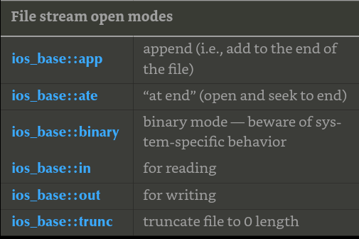
11.3 File Opening and Positioning
- As seen from C++, a file is an abstraction of what the OS provides. A file is a sequence of bytes numbered from 0 upward. The question is how we access those bytes
- File open modes. ifstream and ofstream for opening a file for input and output respectively.
  - fstream(“myfile”, ios_base::in|ios_base::out); → both in and out. (The | is bitwise or that can combine modes)
  - ofstream ofs {name, ios_base::app}; → appends to the end, good for writing log files
- If an operating system cannot honor a request to open a file in a certain way, the result will be a stream that is not in the good() state
  - ifstream ifs {“readings”}; if(!ifs) //error cannot open readings for reading
  - Typically if an operating system cannot find a file, it will create a new file, but IT WILL NOT CREATE A NEW FILE IF TRYING TO OPEN A NONEXISTENT FILE FOR INPUT
- Stick to reading files opened as istreams and writing to opened files as ostreams
11.3.2 Binary files – I really just don’t understand it completely
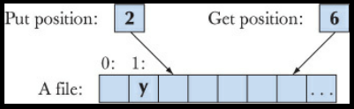
- Whenever possible, read and write from the beginning to the end. It’s the easiest and least error-prone way
- Every file that is open for reading has a read/get position and every file open for writing has a write/put position
  - fstream fs{name};
  - if (!fs) error(“cant open “, name};
  - fs.seekg(5); //move reading position (g for “get”) to 5 (the 6th character)
  - //use seekp for put
  - NOTE: After use, seekp and seekg increment their positions
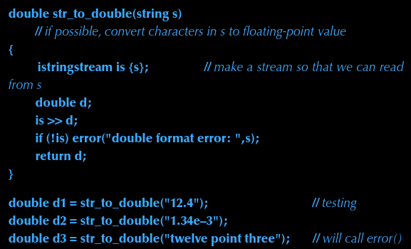
  - Undefined behavior if trying to seek beyond the end of a file, and operating systems do really differ

11.4 String Streams
- Strings can be the source for a istream or target for a ostream called istringstream and ostringstream respectively. For example, an istringstream can be useful for extracting numeric values from a string
  - Example to the right
- If trying to read beyond end of an input string stream’s stream, it will go into eof() state meaning we can use the “usual input loop” for a input string stream
- The str() member function of ostringstream returns the string composed by the output operations to an ostringstream, the c_str() is a member function of string that returns a C-style string
- String streams generally used when we want to separate actual I/O from processing.
- Simple use of ostringstream is to construct strings by concatenation
  - int seq_no = get_next_number(); // get the number of a log file
  - ostringstream name;
  - name << "myfile" << seq_no << ".log"; // e.g., myfile17.log
  - ofstream logfile{name.str()}; // e.g., open myfile17.log
- Usually, we initialize an istringstream with a string and then read the characters from that string using input operations. Conversely, we typically initialize an ostringstream to the empty string and then fill it using output operations.
  - A more direct way of accessing characters in a string stream that is sometimes usesfil is ss.str() that returns a copy of ss’s string, and ss.str(s) sets ss’s string to a copy of s
11.5 Line-Oriented Input
- The >> operator reads into objects of a given type according to the standard format. An int with >> will read until it encounters something that is not a digit, and string will read until whitespace
- cin reads character by character, getline() reads the ENTIRE line and decides how to format it later
  - string command;
  - getline(cin, command); // read the line
  - stringstream ss {command};
  - vector<string> words;
  - for (string s; ss>>s; )
  - words.push_back(s); // extract the individual words
11.6 Character Classification
- Reading down to the character is more work, but we have full control over what is being done
  - isspace(char) → returns true if space
  - isdigit(char) → true if a number
  - isalpha(char) → true if alpha
- istream::get() → reads a single character into its argument, does not skip whitespace
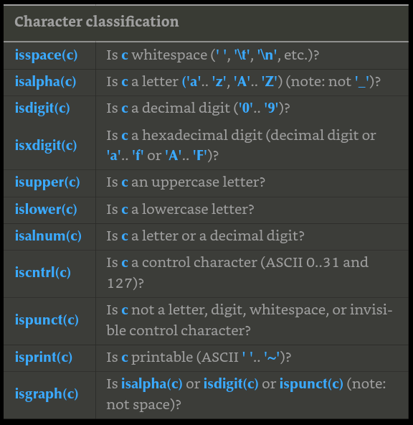
  - Like >>, get() returns a reference to its istream so that we can test its state
- Standard Library functions for testing a char
  - can be combined using the OR operator
  - ignore case differences using toupper(char) or tolower(char)
- Use a range based for with a reference to the current character in strings to change it to lower
  - void tolower(string& s)
  - { for (char& x : s) x = tolower(x); }
  - Not every lower case character has an upper case equivalent in languages, such as german, so prefer tolower()
11.7 Using nonstandard separators
- Example program that reads a line, and gets rid of punctuation to have words be by themselves
  - string line;
  - getline(cin, line); // read into line
  - for (char& ch : line) // replace each punctuation character by a space
  - switch(ch) {
  - case ';': case '.': case ',': case '?': case '!':
  - ch = ' ';
  - }
  - stringstream ss {line}; // make an istream ss reading from line
  - vector<string> vs;
  - for (string word; ss>>word; ) // read words without punctuation characters
  - vs.push_back(word);
- There’s an example program of creating a way to add user-defined separator characters to distinguish between sections of words on page 400 and 403

Skipped 12 – 16 talking about graphics and a display model
Chapter 17 – Vector and Free Store

17.1 Intro
- Extend vector by using push_back() and ask vector for number of elements using size().
- All that the hardware directly supports is sequences of bytes. At the lowest level, the computer knows nothing about push_back(), all the computer knows is how to read and write a few bytes at a time

17.2 vector basics
- Numbering of elements in C++ STL always starts from 0. The actual elements in the vectors are numbered 0 to age.size()-1.
  - Vector<double> age(4);
  - age[0]=0.33;
  - age[1]=22.0;
  - age[2]=27.2;
  - age[3]=54.2;
- To make a vector, need one data member to hold its size, and one to hold elements. We need something more than a data structure holding a fixed number of elements. Operations that change the number of elements of a vector, such as push_back(), can’t be implemented if we defined vector to have a fixed number of elements.
  - By using a pointer, we can point to the set of elements, and then change the pointer to point to a new set of elements if the set of elements changes

17.3 Memory, addresses, and pointers
- Computer’s memory is a sequence of bytes, numbered 0 to the last one. An address is the number that indicates an objects location in memory.
- Everything has a memory address. Take int var = 17. This will set aside an int-sized piece of memory for var somewhere and put the value of 17 into that memory.
- We can store and manipulate addresses. The type needed to hold the address of an int is called a “pointer to an int” or an “int pointer” and the notation is int*
- int* ptr = &var → The rvalue uses the unary address of operator to get the address of the object. So if var happens to start at the address 4096, ptr will hold the value 4096. The notation used for the pointer value depends on the system, a common one is hexadecimal
- Basically, we view our computer’s memory as a sequence of bytes numbered from 0 to the memory size minus 1. On some machines that’s a simplification, but as an initial programming model of the memory, it will suffice.
- If you want to view the object pointed to, use the contents of operator, unary *, or dereference operator
  - int x = 17;
  - int* pi = &x;
  - cout << "pi==" << pi << "; contents of pi==" << *pi << "\n";
  - Dereference can also be used as a lvalue for *pi = 27;
- Even though a pointer can be printed as an integer, it is not. Cannot assign an int to an int*. Same with char* and int*. They cannot mix.
  - If you assigned a char address to an int*, and then dereferenced the int*, and assigned it 12345, we would have been writing 1234 to the memory address of the char. That would definitely have changed the value of nearby memory, possibly other chars. This is why this type of assignment is disallowed
  - If you really need to convert an int to a pointer or to convert one pointer type to another, you can use reinterpret_cast
- To find how much memory a type takes up in bytes, use sizeof(). Can do sizeof(int) to see how much an int is on this system

17.4 Free store and pointers
- When you start a C++ program, the compiler sets aside memory for your code (can be called code storage or text storage) and for the global variables you define (called static storage). It also sets aside memory for functions, their arguments and local variables (called stack or automatic storage). The rest of the computers memory is potentially available for other uses, called free.
  - Free store also called the heap
  - double* p = new double[4] → allocates 4 doubles on the free store (heap). The pointer returns the value of the first double (with the 3 others set right aside it)
- Pointer
  - address of the first byte of memory
  - Points to an object of specified type
  - Does not know how many elements it points to. Therefore given a pointer array of size 4, assigning array[6] will be allowed to happen even though its not being tracked. You have now overwritten other memory (called out of range access)
  - Cannot assign an int pointer a double or vice versa. If the sizes are different and the pointer is an array, assigning a double to an int pointer can overflow the next int in the array
  - If using an array, double* p = new double[4]; double y = p[2] → as a way to dereference the array without actually using * operator
  - Doing double* p; *p=7.0; → could be harmless location in memory, could not be.

